Niflr Yourstory

[yourstory.com](https://yourstory.com/2020/10/tech30-bengaluru-startup-niflr-retail-ai-autonomous-stores)

**[Tech30 Special Mention] How Niflr helps brands and retailers set up autonomous stores in unconventional retai**

Sujata Sangwan

5-6 minutes

According to a [study](https://www.digimarc.com/docs/default-source/digimarc-resources/forrester-study.pdf) conducted by **Forrester Research and Digimarc**, the checkout experience and the length of the checkout line at physical retail stores are often the most common reasons why people abandon their shopping carts. This can influence the shopping decisions of almost 40 percent of shoppers, thus making the checkout experience an important area of investment for retailers. More so, to compete with the speed and convenience of online shopping.

**Bengaluru-based Niflr makes this possible with its AI-based autonomous checkout and marketing data platform for retail stores**. With its sensor fusion and computer vision technologies, customers can walk into a store, pick up their products, and easily walkout. After the bill is generated, money is automatically deducted from the user's mobile wallet.

 “With Niflr's autonomous checkout and marketing platform, brands and retailers are enabled with actionable data points like consumer's geographic, demographic, and purchase pattern data.

 “The live inventory on every shelf and the tools to support the dynamic pricing and promotion makes it easy for brands to target users and areas to run campaigns and make decisions like never before. We are focusing right now on helping retailers and brands set up stores in unconventional retail spaces,” **Ankur Sharma, Co-founder, Niflr**, tells *YourStory*.

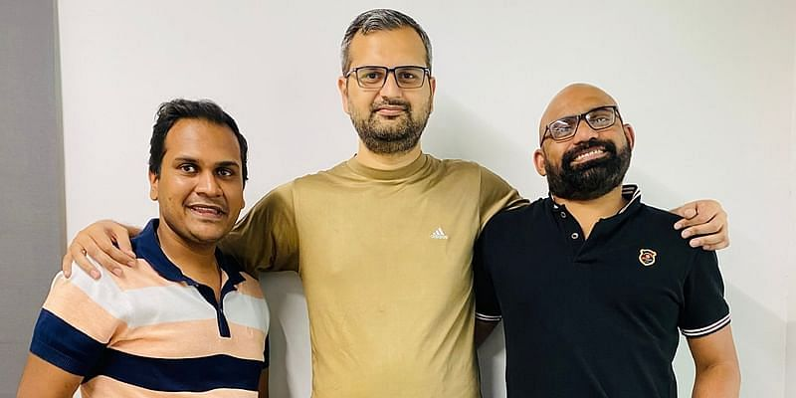

Niflr Founders (L-R): Priyank Garg, Ankur Sharma and Pradeep Vallat

Founded in **July 2017** by **Ankur Sharma**, **Pradeep Vallat**, and **Priyank Garg**, the retail tech startup has made it to the special mentions category of *YourStory’s* curated list of **Tech30** startups this year.

**The dream team**

An MBA graduate from MDI Gurugram, Ankur (36) previously worked with LoginRadius and Alcatel-Lucent. On the other hand, Priyank (36) — an engineering graduate from IIT ISM Dhanbad — has over 13 years of experience, working as the Director of Engineering at 247.ai.

Pradeep (45) — a serial entrepreneur and the CEO of Niflr — has earlier headed startups like CAptchaLive Media and Omllion Technologies. He has a Diploma from NIIT in Computer Programming.

At present, **Niflr has a strong team of about 40 employees.**

**The USP**

The retail-tech startup has developed a platform to keep the computing costs to a minimum while working across all product categories in the retail sector.

With its marketing and live inventory management, it enables brands and retailers to dynamically manage offers and promotions, as well as reduce product dumping.

Besides, the Niflr platform provides **customer data at the hyperlocal level** and allows brands and retailers to communicate with their customers in real-time.

“Today, major autonomous checkout technology providers are based out of the USA, and the implementation cost for these solutions is high at the time. Our modular system is a perfect fit for 50 SKUs to 1,000 SKUs store, and a breakeven can be achieved in less than 15-18 months,” Ankur says.

**Moving forward**

Earlier, in April 2020, the startup raised an **angel round of funding** from **Firstcheque, Letsventure, Upsparks**, and prominent angels, including **Aprameya Radhakrishna** (Co-founder — Taxiforsure and Koo), among others.

**At present, Niflr is in talks with investors to raise $3 million** to set up over 300 autonomous checkout stores in the next 18-24 months. The startup claims to have commitments for **60+ stores from different retailers and brands**.

 “We launched our first store in November 2019. Our second store was launched in June 2020, and the third store went live in August 2020. These stores are owned and operated by Niflr, and we have close to 1500+ customers shopping from these stores. Till now, we have over 50,000+ autonomous checkout done on the platform,” says Ankur.

The retail tech startup directly competes with the likes of **Watasale** in India, and **Zippin, Standard, Trigo, Aifi, Grabango**, and **Amazon Go**, globally. Its indirect competitors are the companies that provide vending machines.

“With our proprietary mix of sensors, computer vision, and industrial design, we have built the solution affordable for the Indian market. The modularity makes it easier for even brands to set up their own footprints. With our technology, we can harness offline store data to enable brands and retailers to communicate and market products effectively,” Ankur adds.

Niflr takes a five percent transaction fee for autonomous checkout. Marketing platform charges are based on targeting criteria and inventory usage. **Last year, the startup generated a revenue of Rs 6 crore, and is expecting to clock Rs 14-15 crore this year**.

According to [Forrester](https://go.forrester.com/blogs/distinguish-hot-from-hype-in-retail-tech-investments-for-2020/), autonomous checkout tech is one of the top investment priorities for retailers and brands. As per a [Business Insider](https://www.businessinsider.in/retail/news/the-in-store-checkout-revolution-how-payments-companies-can-take-advantage-of-a-21-billion-opportunity/articleshow/71490829.cms) report, autonomous checkout technology has seismic repercussions for in-store tech, and by 2024, the total autonomous checkout stores volume will be close to $21 billion.

The number of stores with autonomous checkout is set to rise from 350 in 2018 to 10,000 by 2024, the report added. This will be driven by the convenience it offers to consumers, the savings and revenue it brings to retailers, and the technology's eventual ability to scale.